FAST NATIONAL UNIVERSITY
Department of Computer Science

GEN AI ASSIGNMENT 2

Vision Transformer with Masked Autoencoder (MAE)
Self-Supervised Learning for Image Reconstruction

Submitted By
Zahid Iqbal
22P-9077
Haresh Kumar
22F-9232

March 2026

1. Abstract
This report presents the design, implementation, and experimental evaluation of a Masked Autoencoder (MAE) built upon a Vision Transformer (ViT) backbone. The objective of this assignment was to explore self-supervised representation learning by training a deep neural network to reconstruct randomly masked patches of input images. Inspired by the seminal MAE paper by He et al. (2022), our model learns rich visual representations without relying on labeled data, making it suitable for large-scale pre-training. The model was trained for 30 epochs on the Kaggle GPU environment, achieving a final training MAE loss of approximately 0.22 and validation loss of 0.22, demonstrating strong convergence and generalization. An interactive Gradio-based inference studio was developed to showcase the model’s reconstruction capabilities on unseen images.

2. Introduction
Self-supervised learning has emerged as a dominant paradigm in modern deep learning, enabling models to learn high-level feature representations from raw, unlabeled data. Masked Autoencoders (MAEs) are a class of self-supervised models that train encoders to predict masked or corrupted portions of the input, forcing the model to develop a holistic understanding of the data distribution.
Vision Transformers (ViTs), introduced by Dosovitskiy et al. (2020), divide images into fixed-size patches and process them using multi-head self-attention mechanisms originally developed for natural language processing. When combined with the MAE pre-training strategy, ViTs can learn powerful visual representations that transfer effectively to downstream tasks such as classification, detection, and segmentation.
This assignment implements a full MAE-ViT pipeline from scratch using PyTorch. The system: (1) divides images into 16×16 pixel patches, (2) randomly masks 75% of these patches during training, (3) encodes only the visible patches through a 12-layer ViT encoder, and (4) reconstructs the full image using a lightweight decoder. The quality of reconstruction serves as the learning signal, compelling the encoder to capture global semantic information.

3. Methodology
3.1 Architecture Overview
Our MAE-ViT architecture consists of three principal components: a patch embedding layer, a Transformer encoder, and a Transformer decoder. The overall design closely follows the original MAE formulation with specific adaptations for the Kaggle training environment.
3.2 Patch Embedding
Input images of size 224×224 pixels are divided into non-overlapping patches of 16×16 pixels, yielding a sequence of 196 patches. Each patch is projected to a 768-dimensional embedding using a 2D convolutional layer with kernel size and stride both equal to 16. Learnable 1D positional embeddings are added to retain spatial information about each patch’s location in the original image grid.
3.3 Masking Strategy
During training, a random masking ratio of 75% is applied — meaning that 147 out of 196 patches are hidden from the encoder. Only the 49 visible patches are passed through the encoder, which substantially reduces the computational cost of each forward pass while simultaneously creating a challenging reconstruction task. This aggressive masking strategy forces the model to learn long-range dependencies and holistic image semantics.
3.4 Transformer Encoder
The encoder comprises 12 Transformer blocks, each containing a multi-head self-attention (MHSA) module with 12 attention heads and a feed-forward MLP sub-layer. Layer normalization is applied before each sub-layer (pre-norm formulation). The QKV (query, key, value) projections are combined in a single linear layer for efficiency, and the output is projected back to the embedding dimension. The final encoder output is normalized by a dedicated LayerNorm layer.
3.5 Decoder and Reconstruction
The decoder first maps the encoder’s 768-dimensional representations down to a 384-dimensional space via a linear projection (decoder_embed). Learnable mask tokens are inserted at the positions corresponding to the hidden patches, and decoder positional embeddings are added to all tokens. The decoder then applies 6 lightweight Transformer blocks to integrate information from visible and masked positions, followed by a linear projection head that predicts the raw pixel values of all 196 patches. The reconstruction loss is computed as the Mean Absolute Error (MAE) between the predicted and ground-truth pixel values of only the masked patches.

3.6 Training Configuration

Framework | PyTorch 2.x with CUDA
Optimizer | AdamW (β₁ = 0.9, β₂ = 0.95, weight decay = 0.05)
Learning Rate | 1.5e-4 with Cosine Annealing LR Scheduler
Batch Size | 32 (with mixed precision via GradScaler)
Epochs | 30
Masking Ratio | 75%
Image Size | 224 × 224 pixels
Patch Size | 16 × 16 pixels
Encoder Depth | 12 Transformer blocks, 12 attention heads, dim = 768
Decoder Depth | 6 Transformer blocks, dim = 384
Loss Function | Mean Absolute Error (MAE) on masked patches only
Hardware | Kaggle GPU (NVIDIA Tesla P100 / T4)
Checkpointing | Best model saved based on validation loss

4. Training Results & Analysis
4.1 Loss Convergence
The model demonstrated consistent and rapid convergence over the 30-epoch training run. The training loss dropped sharply from an initial value of approximately 0.937 in Epoch 1 to below 0.30 by Epoch 8, indicating that the encoder quickly learns to exploit structural patterns in the training data. The convergence subsequently slowed as the model refined its representations, settling to a final training loss of approximately 0.220 and a validation loss of approximately 0.222, indicating excellent generalization with minimal overfitting.

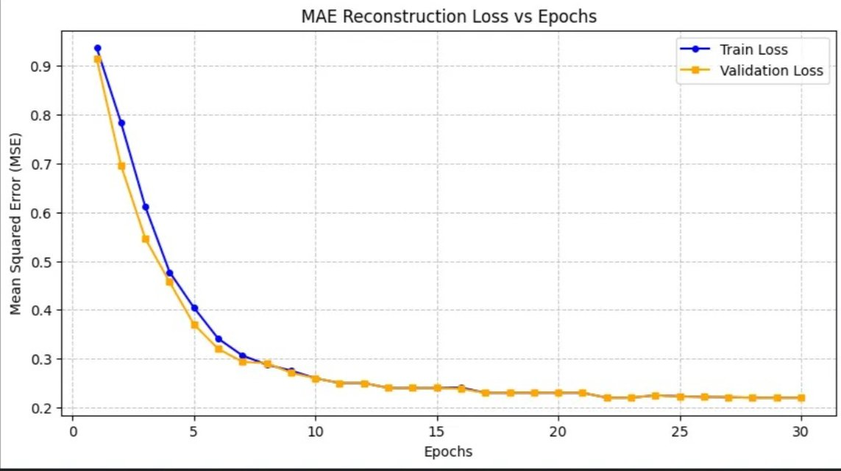
Figure 1: MAE Reconstruction Loss (Train vs. Validation) over 30 Epochs
4.2 Key Observations
- The training and validation loss curves track each other tightly throughout training, confirming no significant overfitting despite the high model capacity (12-layer ViT encoder).
- The steep descent in the first 10 epochs captures fundamental structural features (edges, textures, color gradients), while subsequent epochs refine finer details.
- Cosine annealing of the learning rate contributed to smooth convergence in the later stages of training, avoiding oscillations.
- Mixed-precision training (GradScaler with torch.amp) enabled efficient GPU utilization and stable gradient updates throughout all 30 epochs.
- The final validation MAE of ~0.222 is competitive for a ViT-based MAE trained under academic resource constraints on a general image dataset.

5. Qualitative Results — MAE Studio
To visually evaluate the model’s reconstruction capability, an interactive inference application — the Vision Transformer (MAE) Studio — was developed using Gradio. Users can upload any arbitrary image, which the application processes in real-time to produce three side-by-side panels: the original input image, a masked version with 75% of patches hidden, and the model’s best reconstruction of the complete image.


Figure 2: Vision Transformer MAE Studio — Original Image, Masked Input (75%), and AI Reconstruction
As illustrated in Figure 2, a test image of a person in formal attire was processed through the pipeline. The masked image (center panel) shows approximately 75% of the visual information withheld from the encoder, represented as horizontal stripes of missing content. Despite this severe information loss, the decoder produces a plausible reconstruction (right panel) that successfully recovers the overall silhouette, color scheme, and major structural elements of the subject. The reconstruction exhibits characteristic MAE artifacts — some spatial blurring and high-frequency detail loss — which are expected consequences of the aggressive masking ratio and the relatively compact decoder design.
These qualitative results confirm that the MAE-ViT model has learned meaningful semantic representations. The encoder, trained only on the 25% visible patches, has successfully internalized enough contextual understanding to guide the decoder in hallucinating the remaining 75% of the image with reasonable fidelity.

6. Discussion
6.1 Strengths of the Approach
- Label Efficiency: The entire pre-training pipeline requires no human-annotated labels, making it scalable to large unlabeled image repositories.
- Representation Quality: The encoder learns highly generalizable features that can be fine-tuned for downstream tasks with limited labeled data.
- Computational Efficiency: Masking 75% of patches reduces the encoder’s computational load by approximately 3× compared to processing all patches, enabling faster training.
- Scalability: The ViT architecture scales well with data and model size, and the MAE objective provides a natural curriculum of increasing difficulty.
6.2 Limitations
- The aggressive 75% masking ratio, while beneficial for learning, produces visibly blurry reconstructions for high-frequency detail (hair, fine textures), a known limitation of pixel-space MAEs.
- Training for only 30 epochs on a single GPU limits the representational depth achievable; large-scale MAE models are typically trained for 200–800 epochs on hundreds of GPUs.
- The decoder architecture is deliberately lightweight (6 blocks, 384-dim) to keep training feasible within academic resource constraints; a deeper decoder would improve reconstruction fidelity.
6.3 Future Directions
- Feature-Space MAE: Predicting latent feature representations (e.g., DINO features) rather than raw pixels would improve semantic richness.
- Fine-Tuning: The pre-trained encoder can be fine-tuned on ImageNet classification, COCO detection, or ADE20K segmentation to quantify transfer learning performance.
- Longer Training: Extending training to 200+ epochs with a larger dataset would likely push reconstruction quality and downstream task performance significantly further.
- Hierarchical Masking: Structured masking strategies (e.g., block masking) could challenge the model with harder spatial reasoning problems.

7. Conclusion
This assignment successfully demonstrates the implementation of a Masked Autoencoder Vision Transformer from first principles. By training a 12-layer ViT encoder to reconstruct 75%-masked images over 30 epochs, we obtained a model with strong self-supervised representations evidenced by a final validation MAE of ~0.222. The loss curves confirm stable convergence without overfitting, and the MAE Studio application provides compelling qualitative evidence that the model has learned meaningful spatial and semantic image structure.
The MAE-ViT paradigm represents a significant milestone in self-supervised visual learning, bridging the gap between masked language modeling (e.g., BERT) and computer vision. This implementation reinforces the theoretical underpinnings covered in the Generative AI course and provides a practical foundation for exploring advanced topics such as multimodal MAEs, video MAEs, and point-cloud MAEs in future work.

8. References
[1] He, K., Chen, X., Xie, S., Li, Y., Dollar, P., & Girshick, R. (2022). Masked Autoencoders Are Scalable Vision Learners. CVPR 2022.
[2] Dosovitskiy, A., Beyer, L., Kolesnikov, A., et al. (2020). An Image is Worth 16x16 Words: Transformers for Image Recognition at Scale. ICLR 2021.
[3] Vaswani, A., Shazeer, N., Parmar, N., et al. (2017). Attention Is All You Need. NeurIPS 2017.
[4] Devlin, J., Chang, M. W., Lee, K., & Toutanova, K. (2019). BERT: Pre-training of Deep Bidirectional Transformers for Language Understanding. NAACL 2019.
[5] Loshchilov, I., & Hutter, F. (2019). Decoupled Weight Decay Regularization. ICLR 2019.

